Create Java API's fast and simple

Chapter 1: Introduction to Java API's



Lecture 1: Introduction

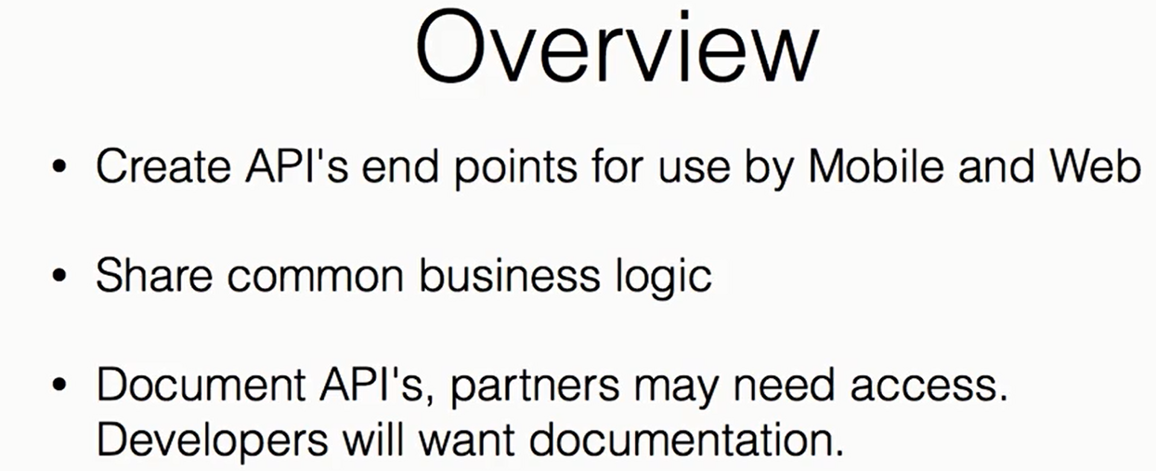

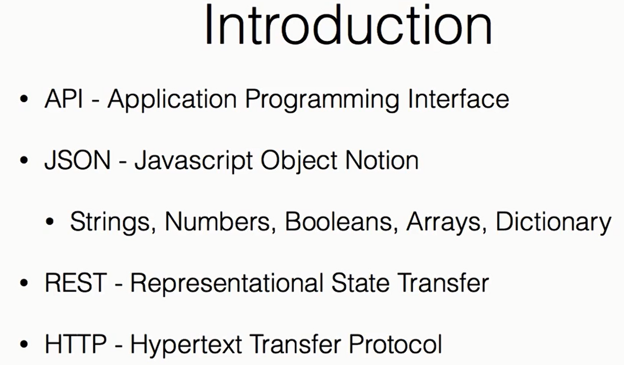

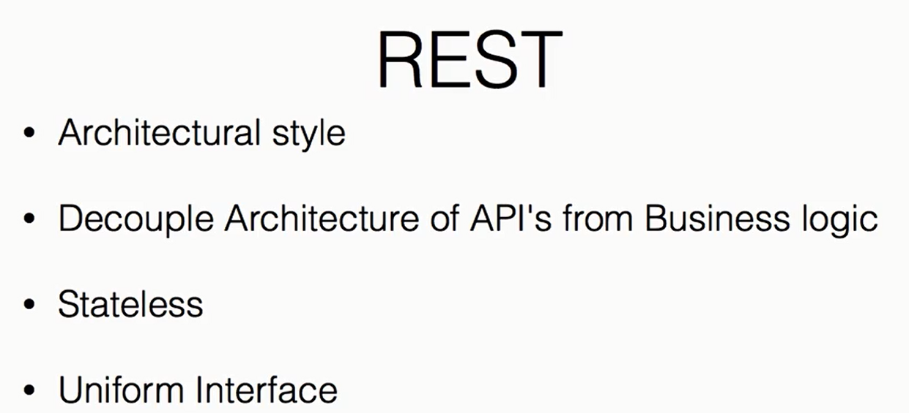

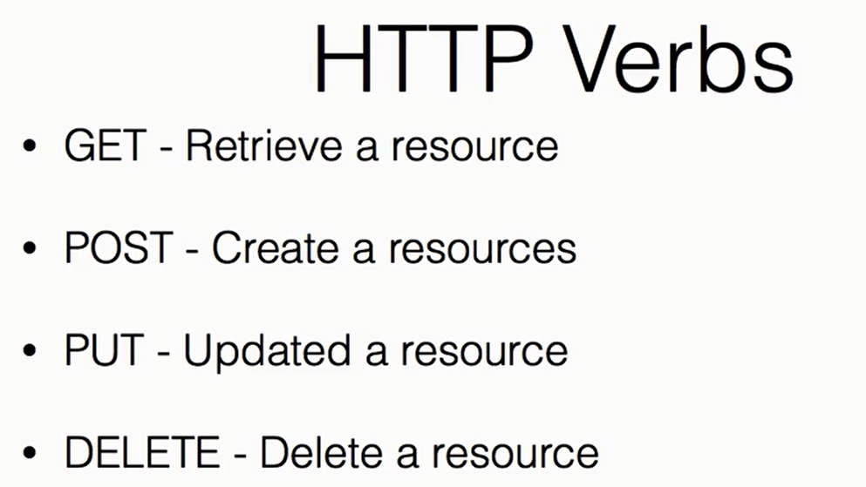

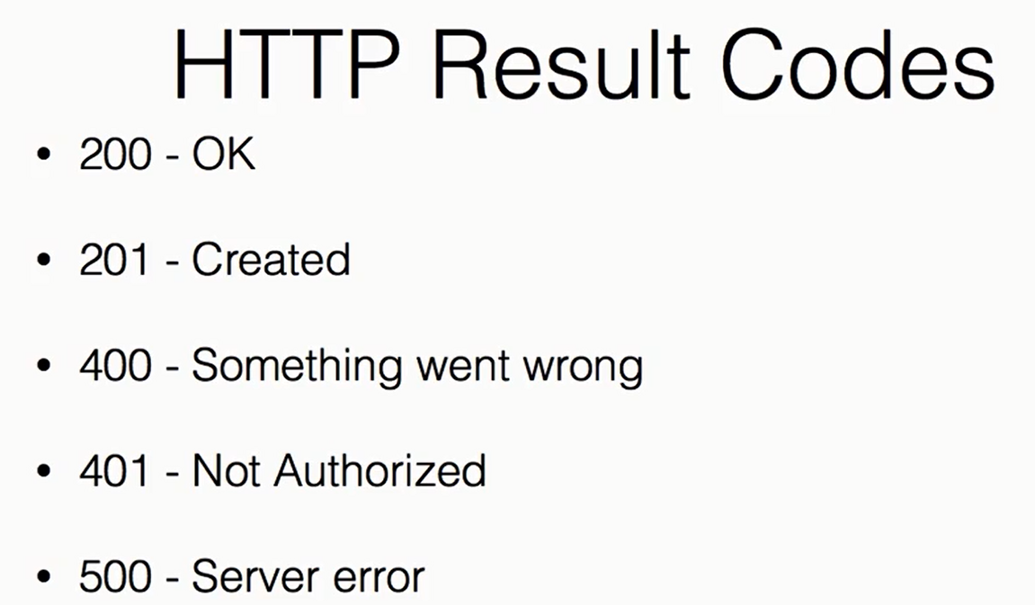

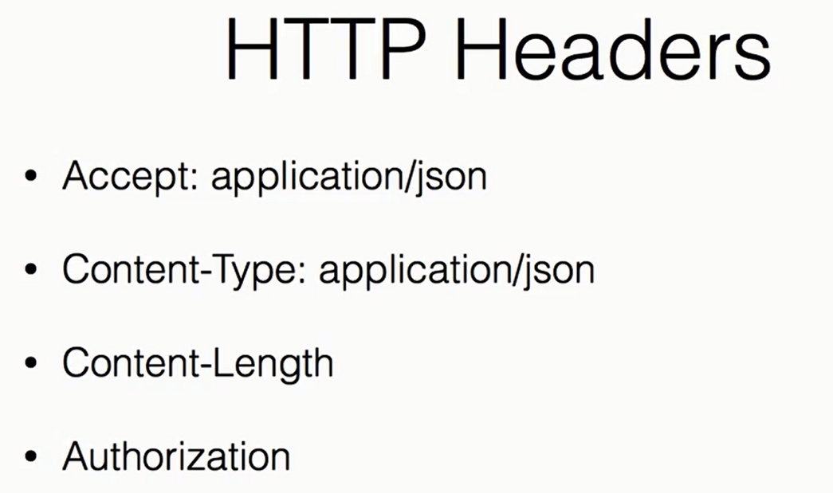

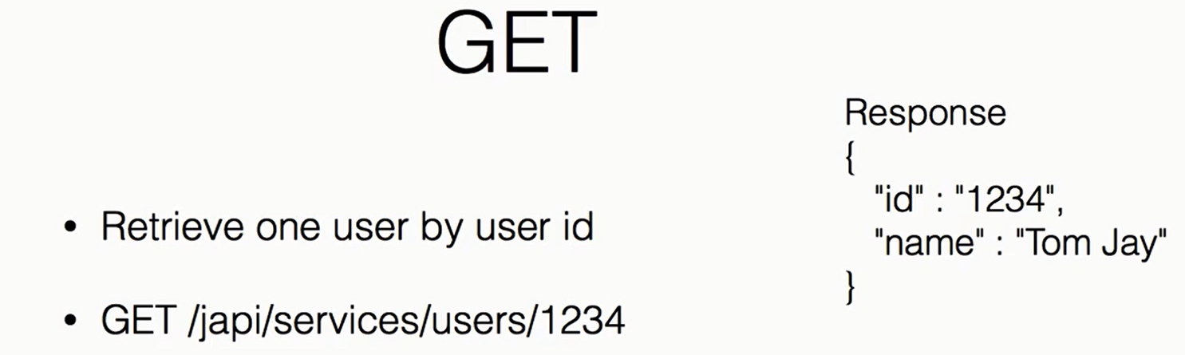

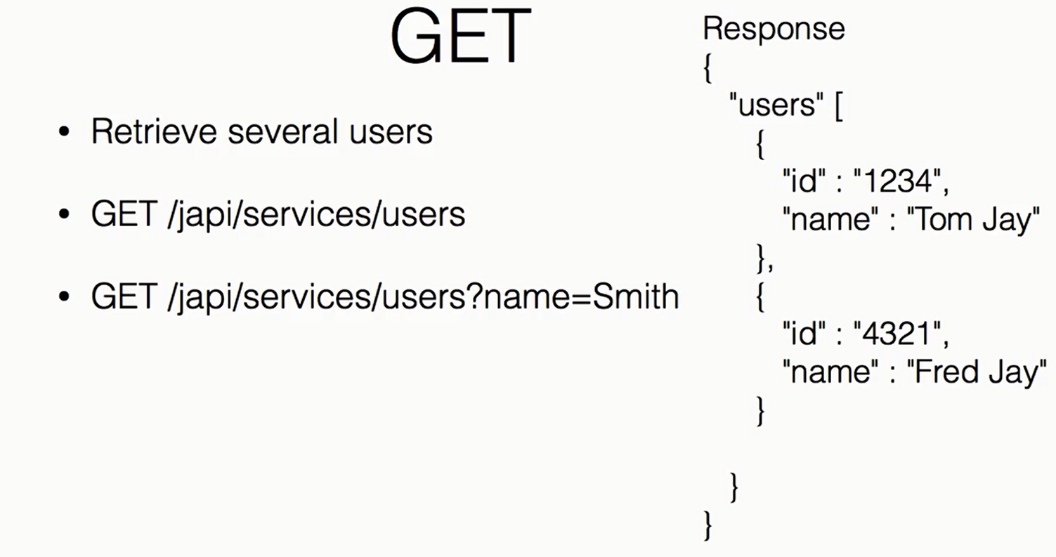

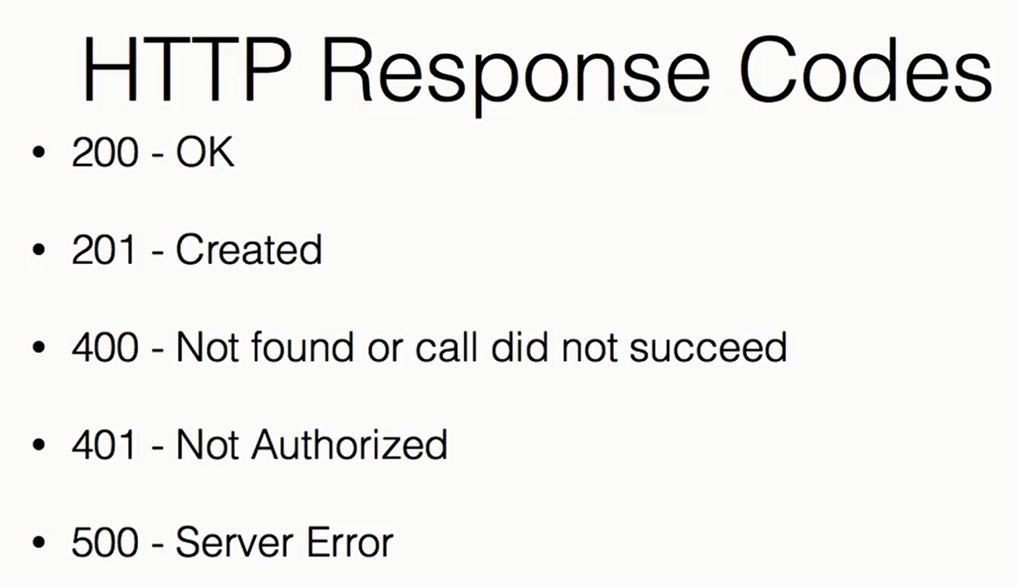

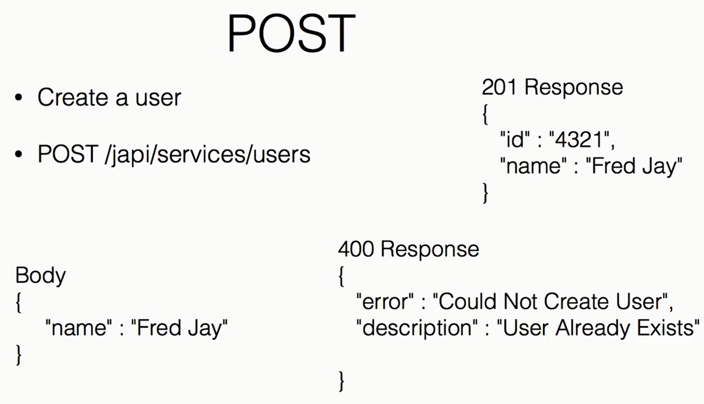

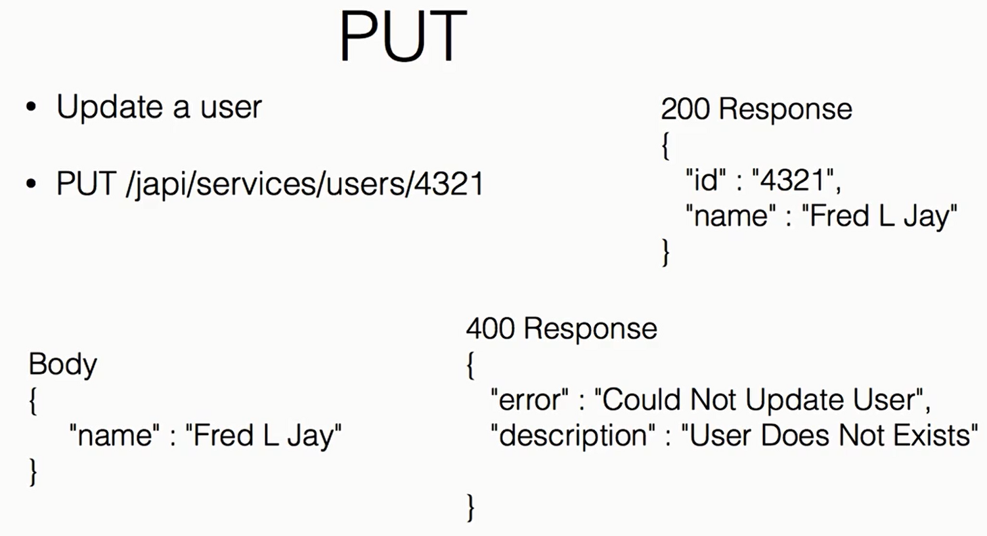

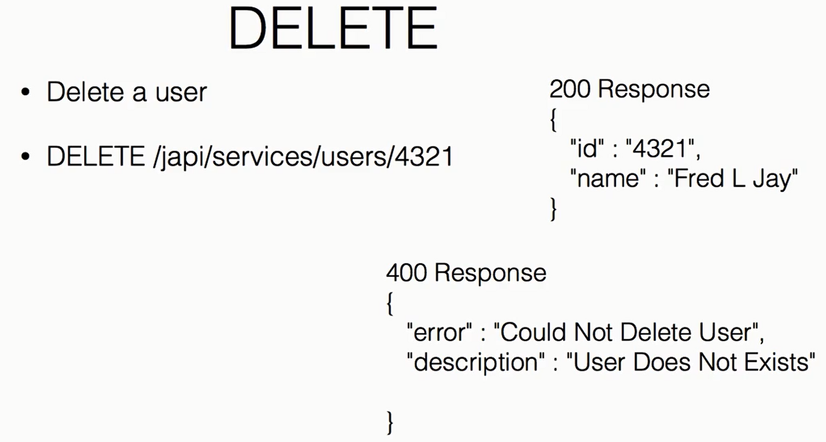

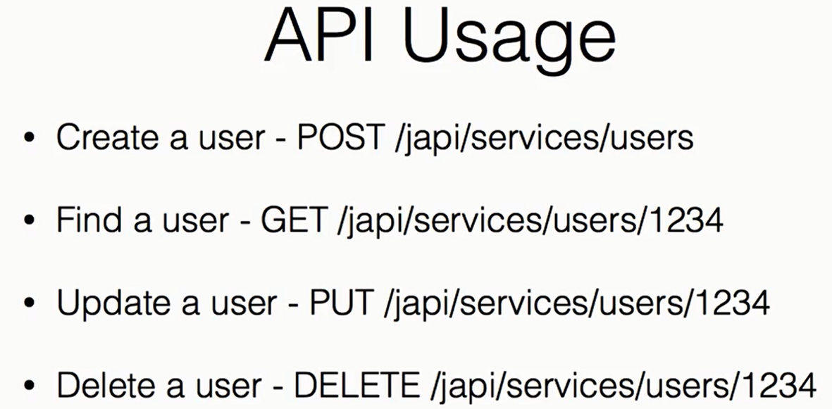

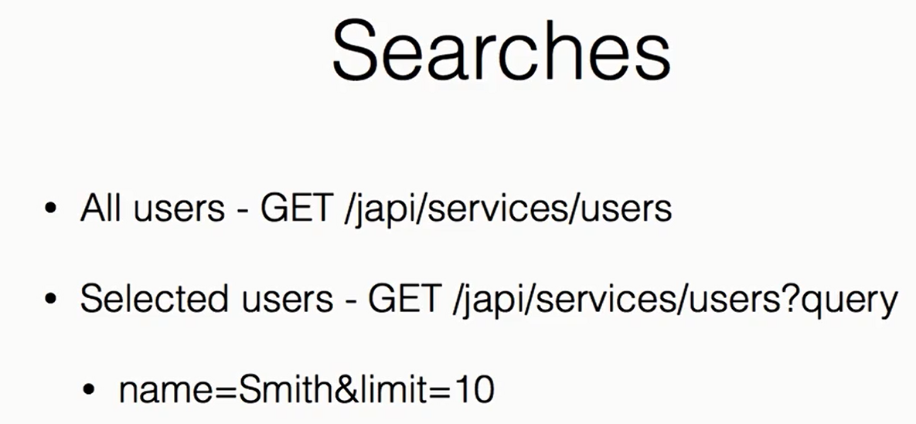

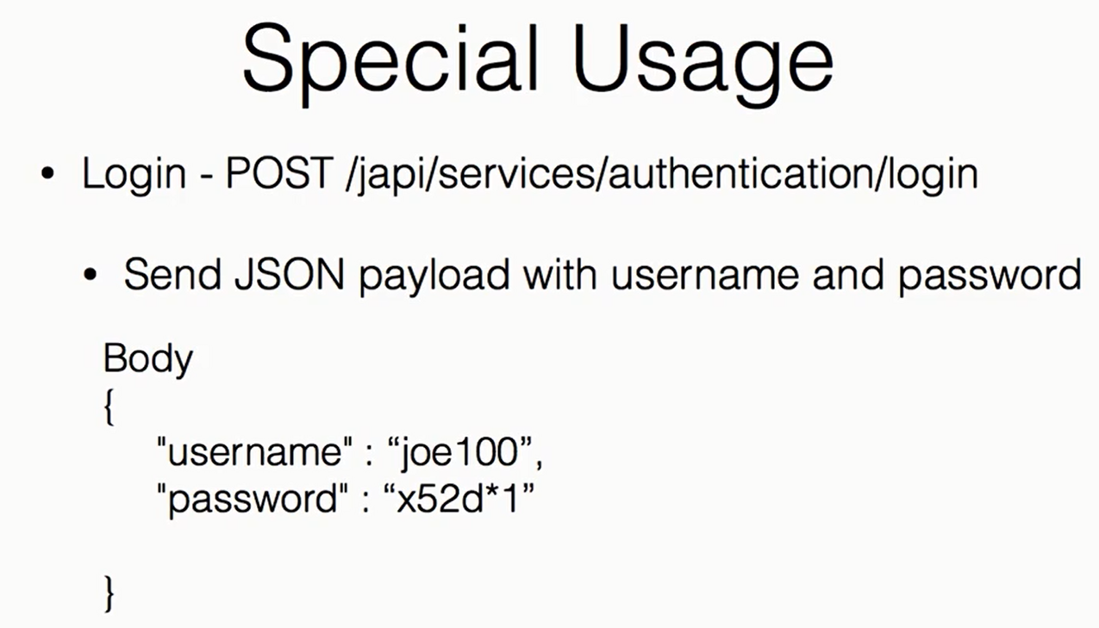

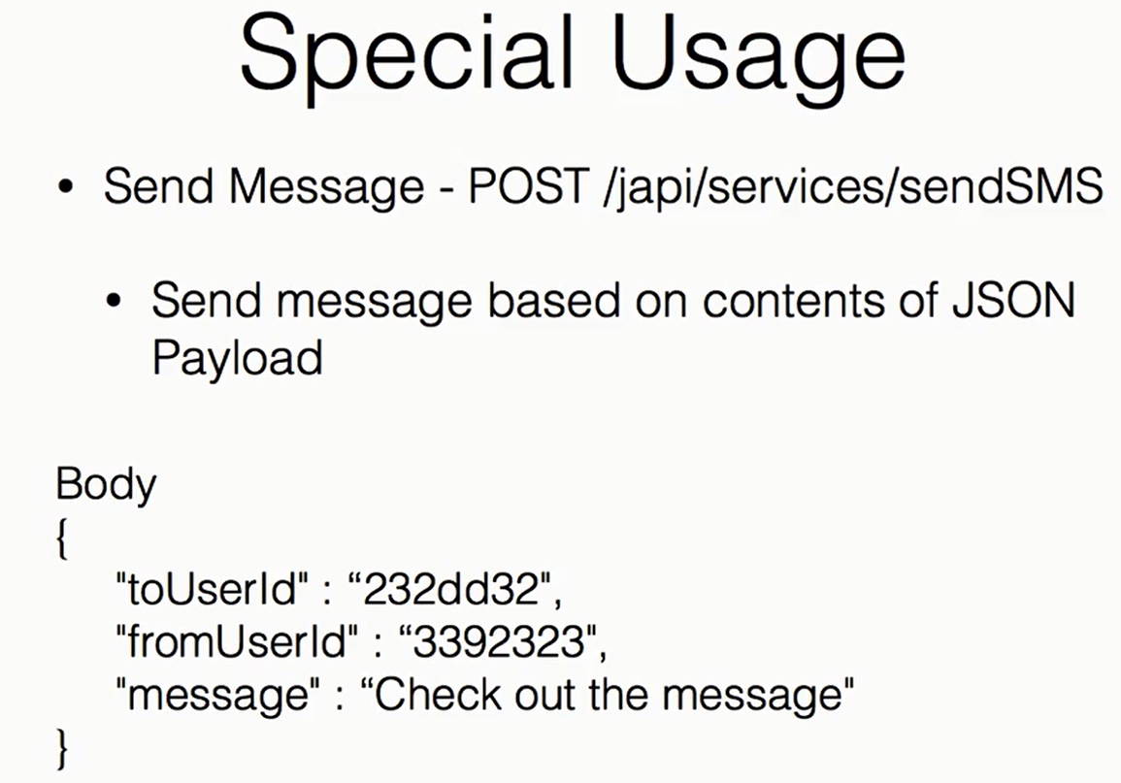

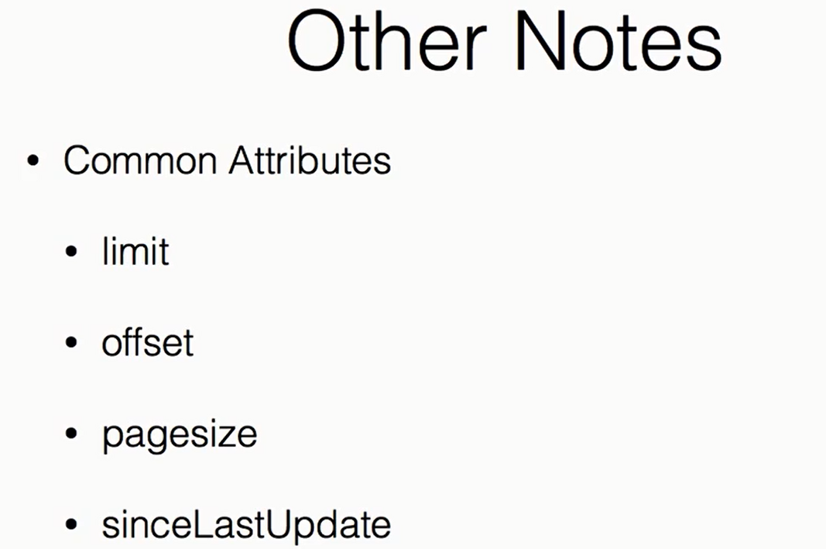

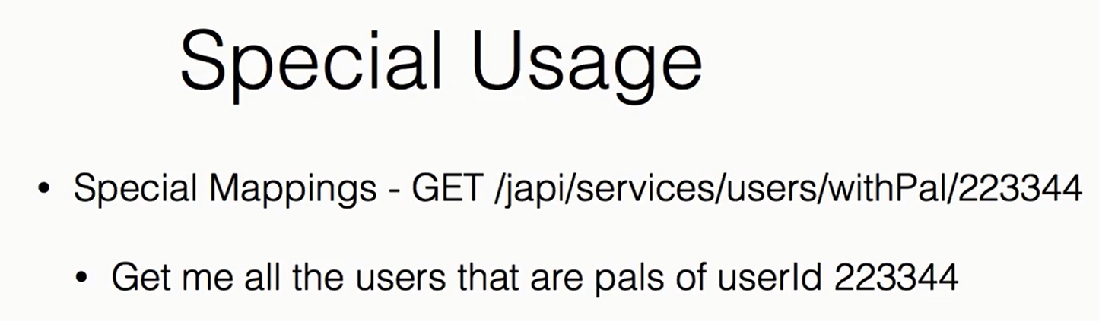

Chapter 2: What is needed

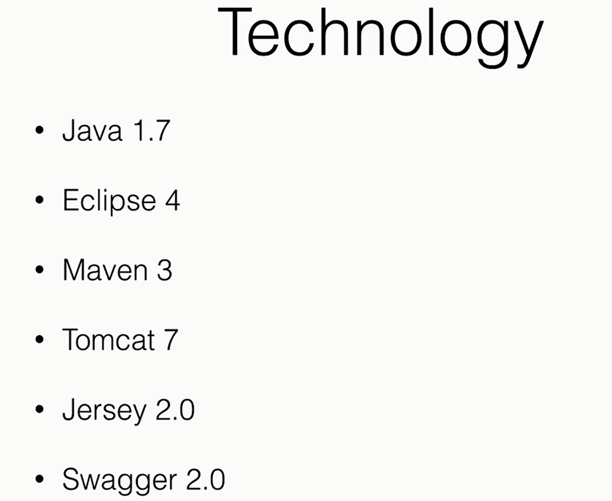

Lecture 2: Getting setup

Add New Maven web project

To remove the following Error:

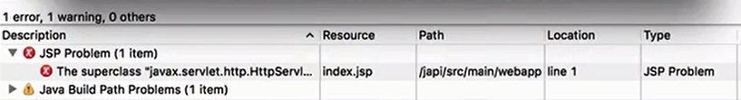

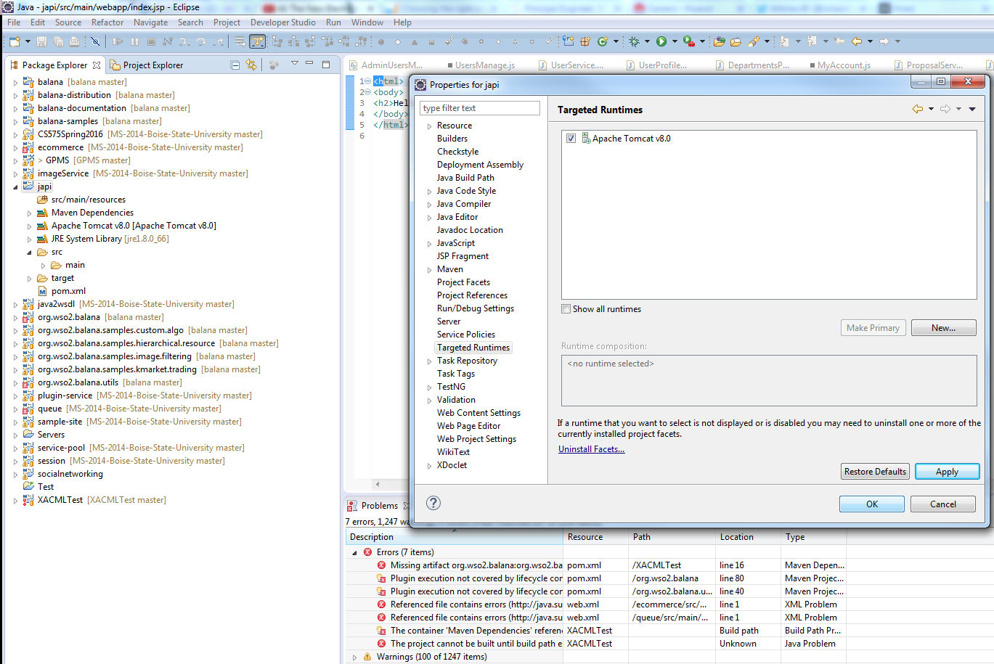

Chapter 3: Start Coding

Adding Swagger dependecy to pom.xml

<https://github.com/swagger-api/swagger-core/wiki/Swagger-Core-Jersey-2.X-Project-Setup-1.5>

<dependency>

<groupId>io.swagger</groupId>

<artifactId>swagger-jersey2-jaxrs</artifactId>

<version>1.5.0</version>

</dependency>

Modify web.xml

Before that need to add few resources in:

Project Explore >> Properties >> Build Path

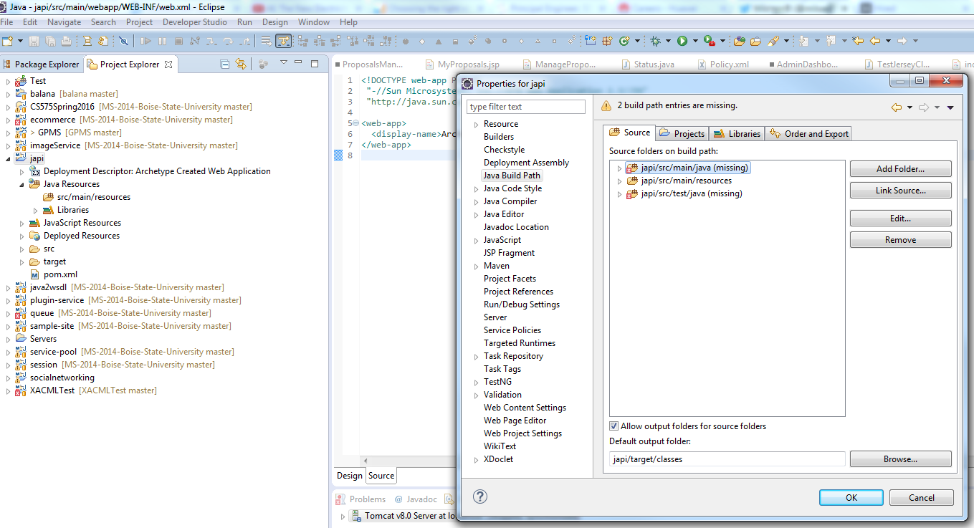

Create those resource folders:

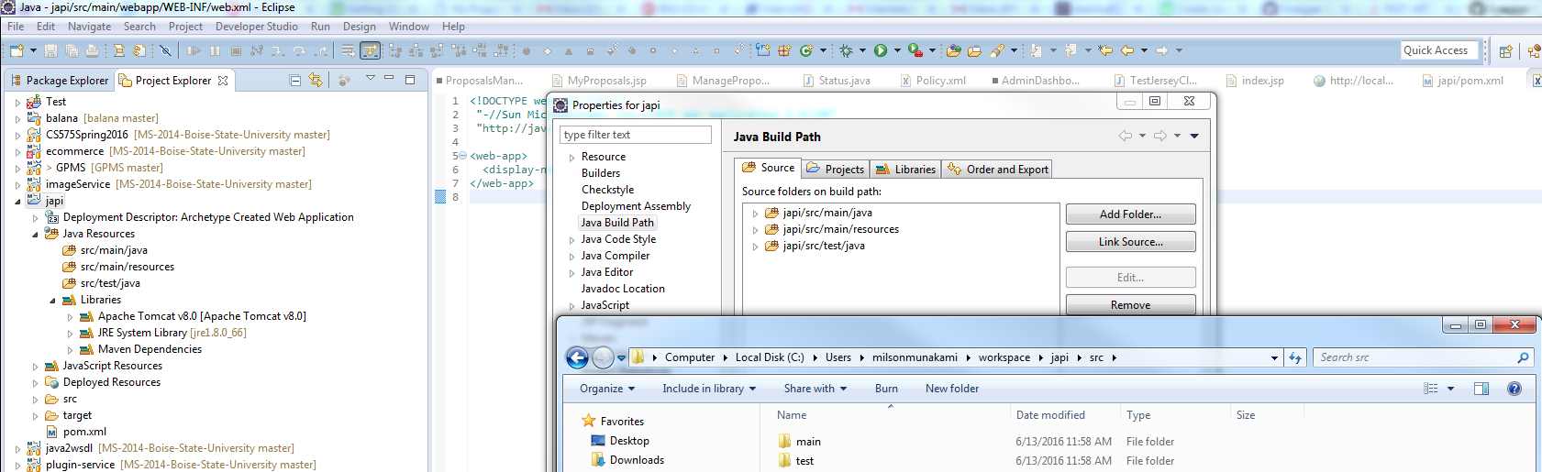

Now the errors will be gone:

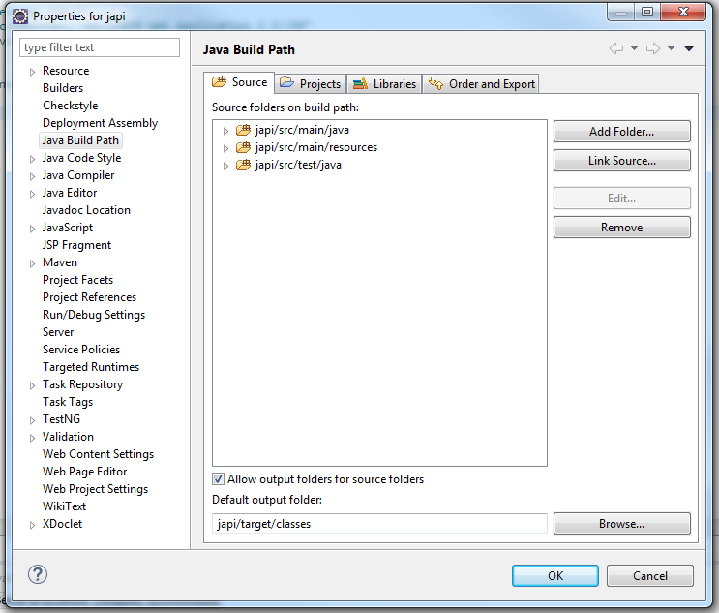

Lecture 3: Starting your project

Create a base package class: 

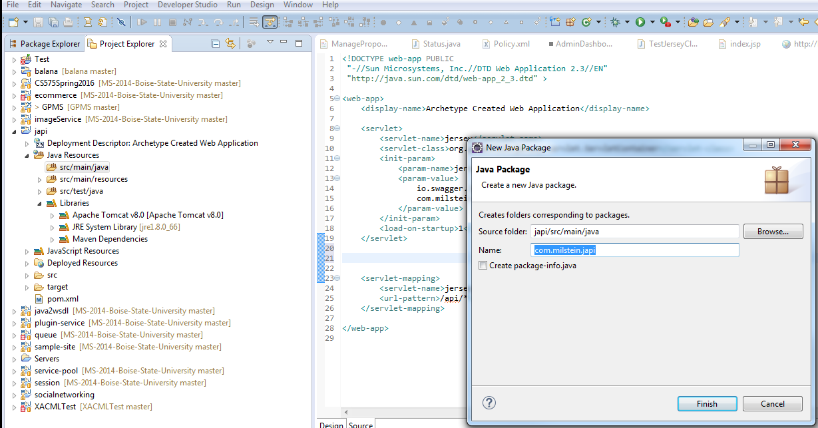

Add New Class for documentation setup:

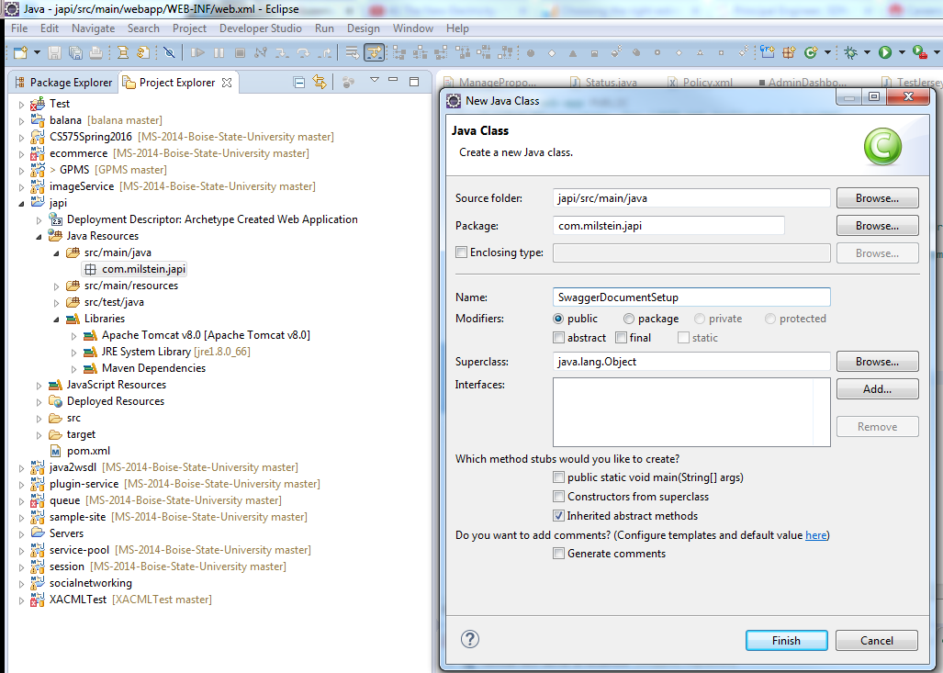

Lecture 4: The first service

Create a new class inside new package as:

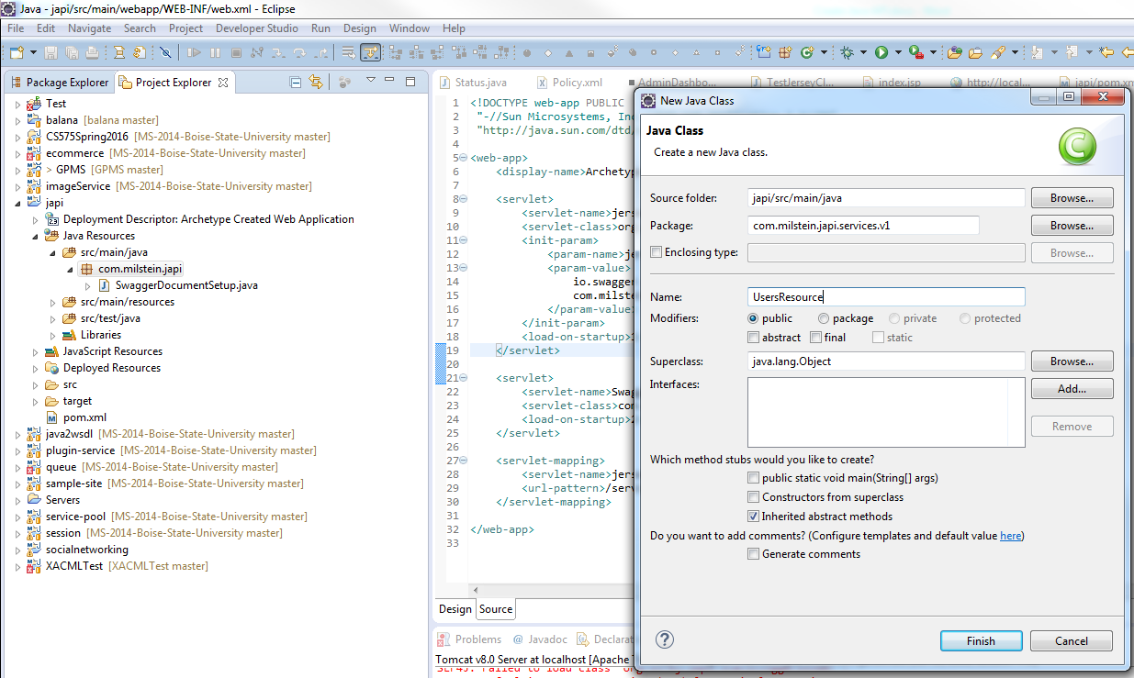

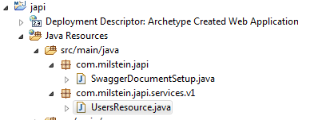

Adding new REST endpoint:

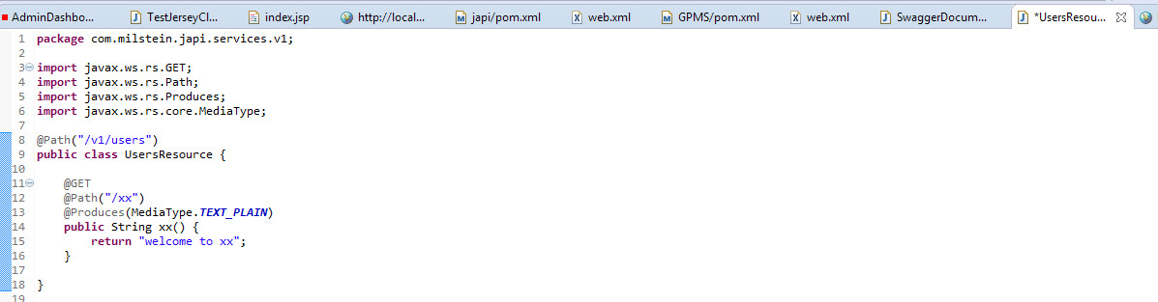

Test:

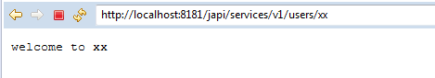

Lecture 5: Getting more formal

So web.xml becomes:

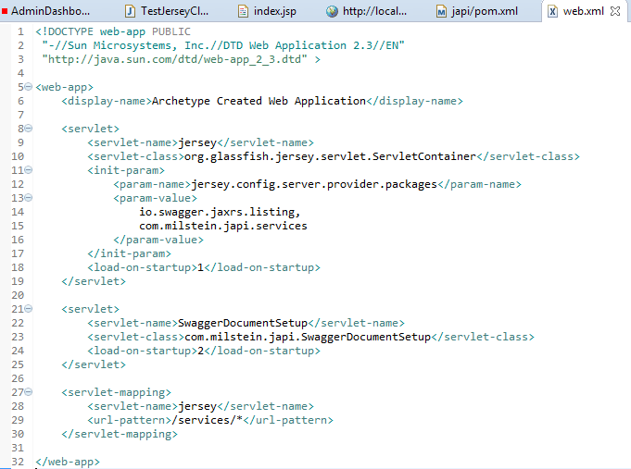

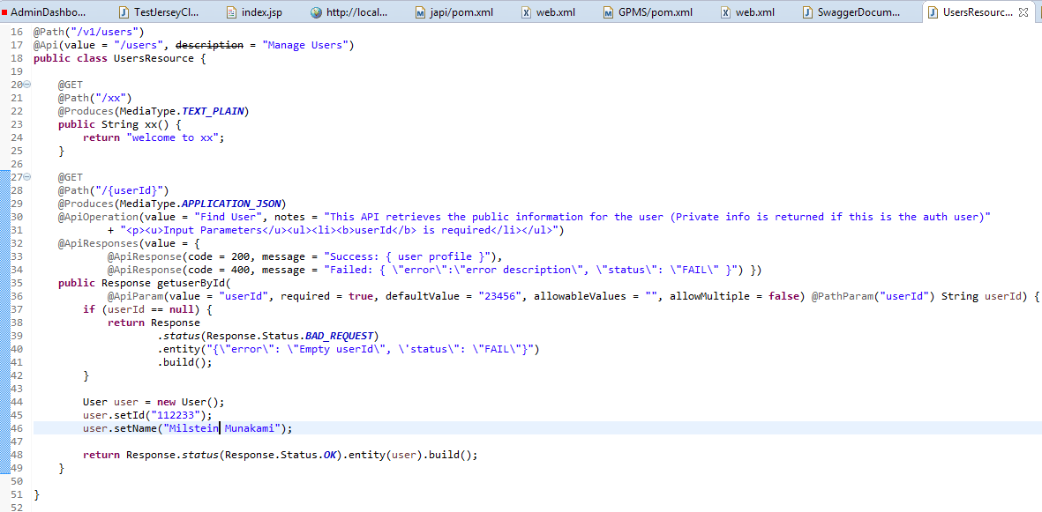

Lecture 6: Making it real

Update the SwaggerDocumentSetup class:

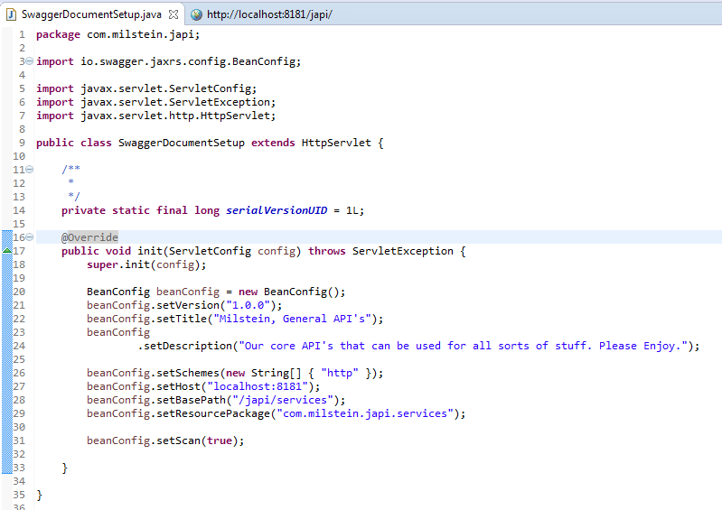

<http://localhost:8181/japi/services/swagger.json>



Go to Swagger UI github repo and download:

<https://github.com/swagger-api/swagger-ui/tree/v2.1.4>

copy all ***dist*** folder’s contain from the zip download to the webapp/api-docs folder

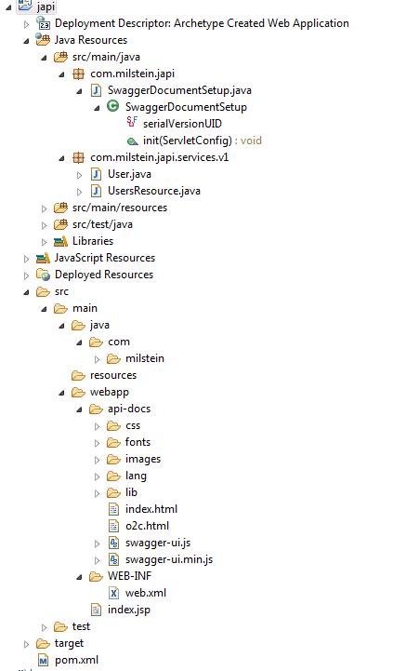

Lecture 7: Adding log4j

Adding dependencies in pom.xml:

<!-- http://mvnrepository.com/artifact/log4j/log4j -->

<dependency>

<groupId>log4j</groupId>

<artifactId>log4j</artifactId>

<version>$(version.log4j)</version>

<exclusions>

<exclusion>

<groupId>com.sun.jax</groupId>

<artifactId>jmxri</artifactId>

</exclusion>

<exclusion>

<groupId>com.sun.jdmk</groupId>

<artifactId>jmxtools</artifactId>

</exclusion>

<exclusion>

<groupId>javax.jms</groupId>

<artifactId>jms</artifactId>

</exclusion>

</exclusions>

</dependency>

Add log4j.properties file:

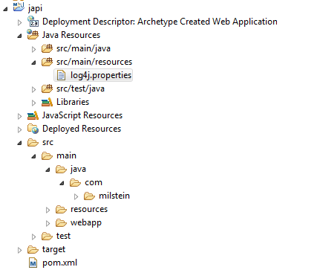

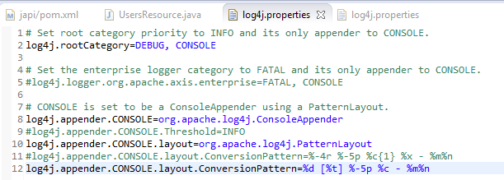

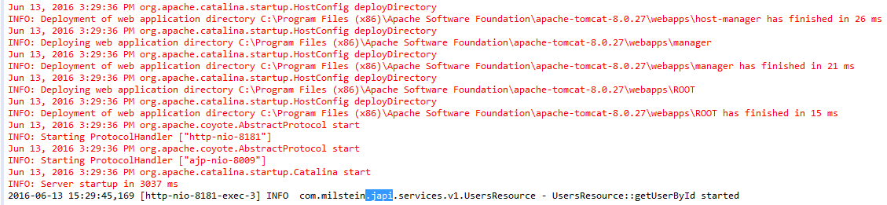

Lecture 8: Business management

Add BusinessManager class in api package and make it a Singleton Instance!

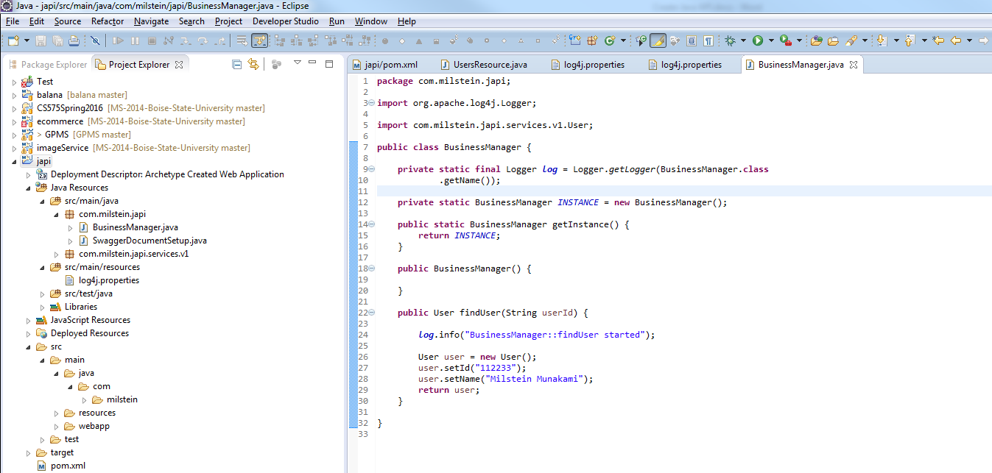

Remove the static code from the UserResource class :

1. Get User By Id():

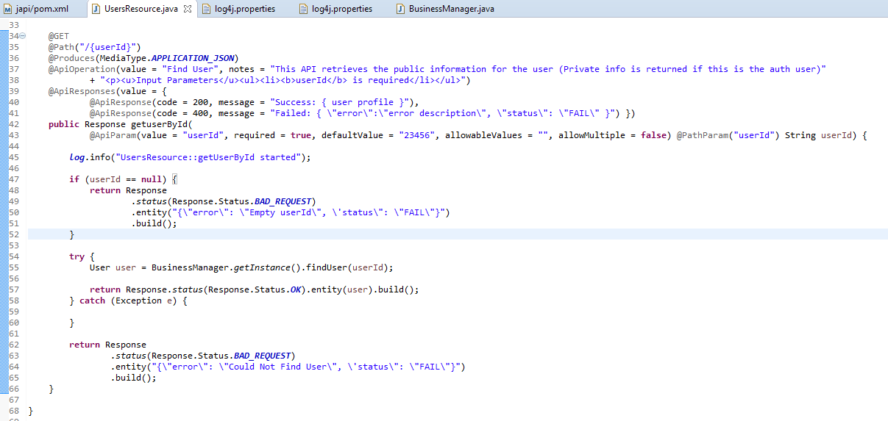

Both classes have log info logged with log4j and we can see following console output:

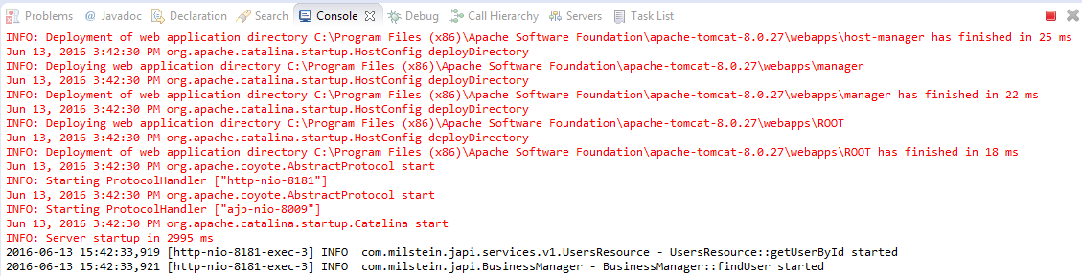

Lecture 9: All API's





1. Add findUsers () Method:

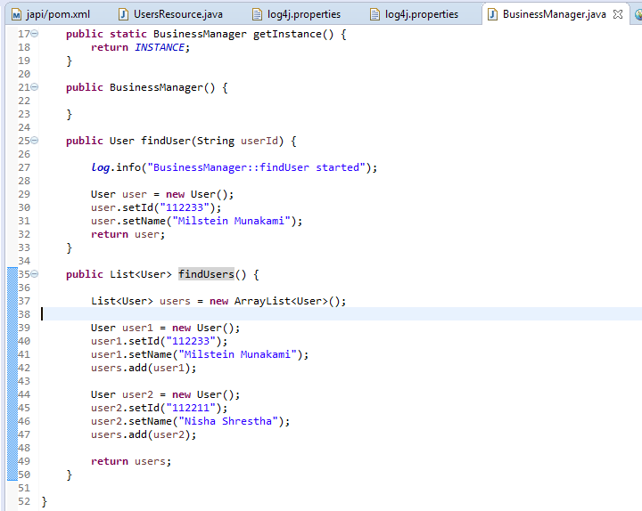

Add new class to hold the list of Users:

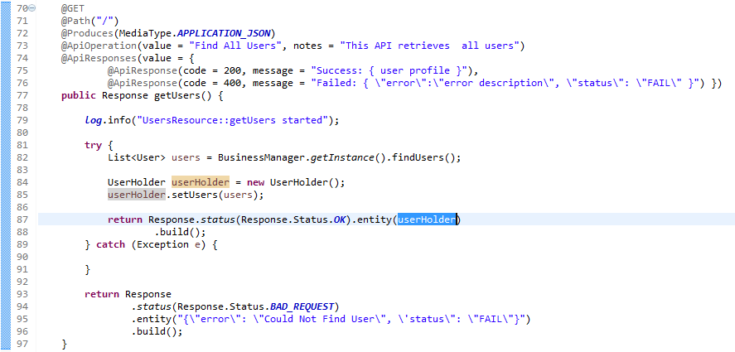

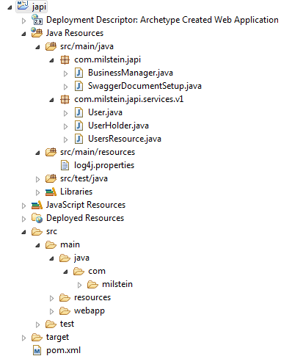

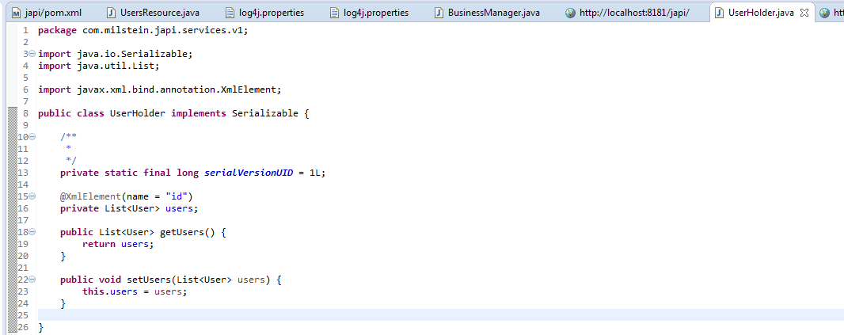

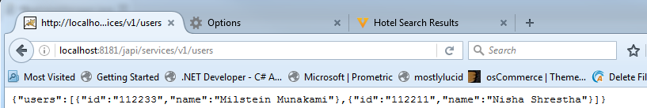

1. POST a New User :

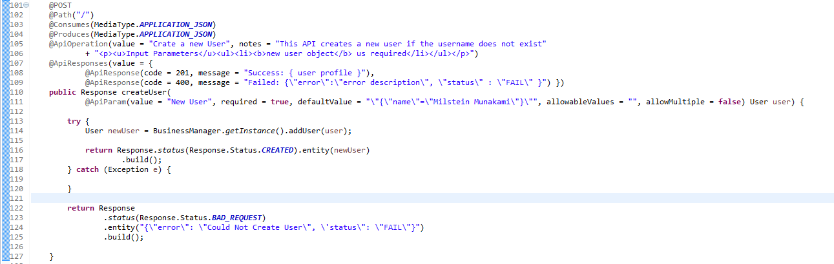

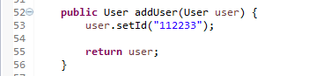

1. Update the User:

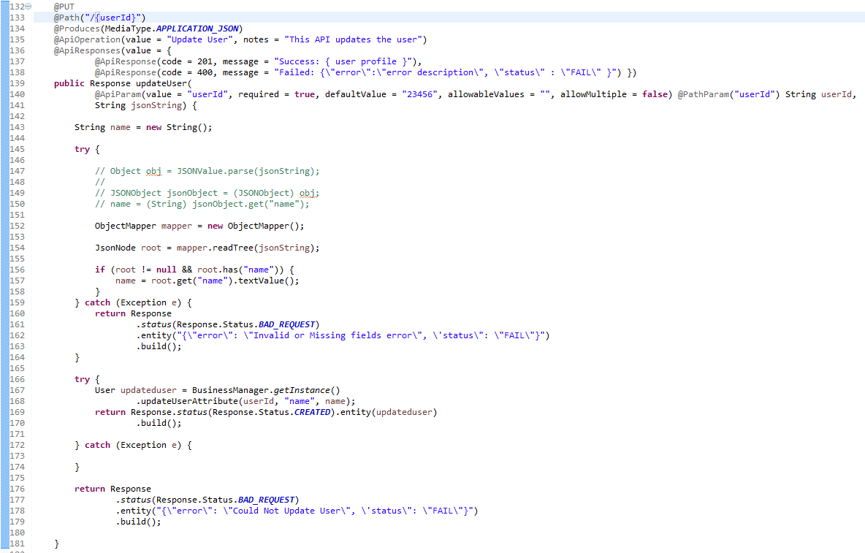

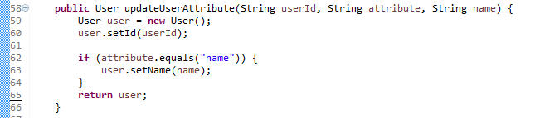

1. Delete a User:

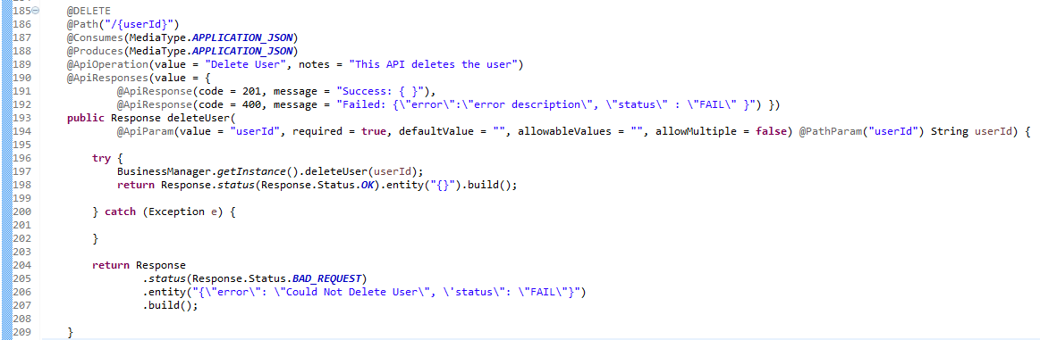



Chapter 4: Database

Lecture 10: MongoDB Integration

Lecture 11: Database continued

Chapter 5: Production Deployment

Lecture 12: Create a war and installing on a server

Chapter 6: Summary

Lecture 13: Thanks

Lecture 14: Source Code

1.